Standard Operating Procedure for Linux VM Connectivity Issue and Troubleshoot

**Resolution:**

* Checked VM logs and found that cloud in it was not picking up the Network devices.
* We could not access the VM via serial console, we needed to troubleshoot the VM.
* We took a snapshot of the OS disk, created a disk and attached the disk to a troubleshooting VM.
* We logged into the troubleshooting VM, chroot into the Linux VM.
* In chroot, we edited the sshd.config file using the command vi /etc/ssh/sshd_config file. modified the permit root login option to yes, uncommented port 22.
* Next, we edited the fallback DNS option in the resolved.conf file using the command vi /etc/systemd/resolved.conf.
* We exited chroot, detached the repaired disk and swapped it with the original VM.
* On serial console, we logged it to VM as root and executed the command dhclient -v.
* We tried to SSH into the VM with Bastion and successfully connected to the VM.

**Steps to describes how to troubleshoot the chroot environment in the Rescue virtual machine (VM) in Linux**:

* Stop or de-allocate the affected VM.
* Create a rescue VM of the same generation, same OS version, in same resource group and location using managed disk.
* Use the Azure portal to take a snapshot of the affected virtual machine's OS disk.
* Create a disk out of the snapshot of the OS disk, and attach it to the Rescue VM.
* Once the disk has been created, Troubleshoot the chroot environment in the Rescue VM.
  1. Access your VM as the root user using the following command:  
      sudo su -  
     b. Find the disk using dmesg (the method you use to discover your new disk may vary). The following example uses **dmesg** to filter on **SCSI** disks:  
      dmesg | grep SCSI

Your output will be similar to the following example. In this example, we want the **sdc** disk:

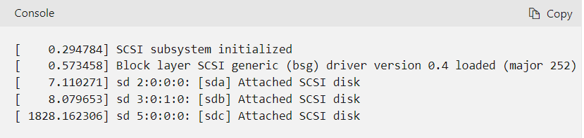

c. Use the following commands to access the chroot environment:

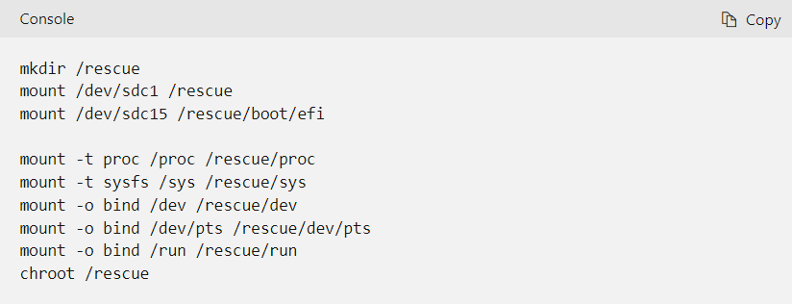

d. Troubleshoot the chroot environment.

e. Use the following commands to exit the chroot environment:

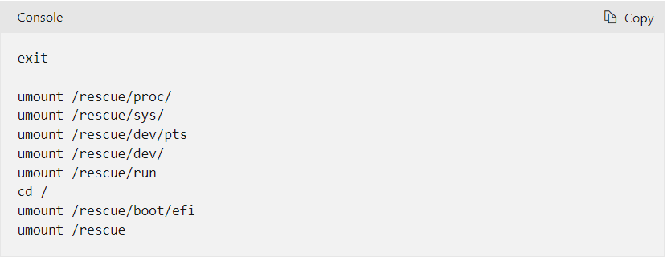

6. Detach the disk from the rescue VM and perform a disk swap with the original VM.

7. Start the original VM and check its connectivity.